Nelson Surgery

Bryncelyn,
Nelson,
Treharris,
CF46 6HL
Tel: 01443 450340

www.nelsonsurgery.co.uk

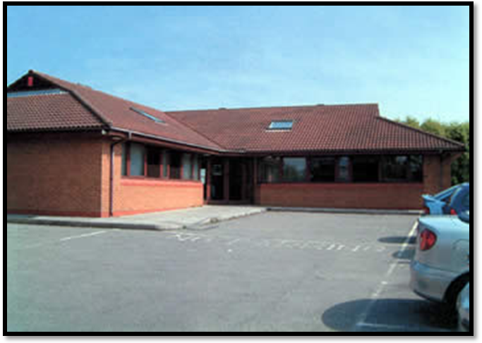

(Senior Partner)

Dr. Abimbola Oluseyi Afelumo (Male) MBBS (Ibadan 1985)

(Locums)

Dr. Sammy Noah (Male) - MBBS (1975 University of Khartoum)

Dr. Mark Mazarelo (Male) - MUDr (1998 University Karlova)

Dr. Pankaj Shah (Male) - MBBS (1972 Gujarat)

We would like to welcome you to Nelson Surgery
(We are not a limited company).

Please keep this leaflet for future reference as it explains the Practice policies and services we provide. Please read it carefully. We trust that you will find it useful.

We are under The Aneurin Bevan University Health Board and the locality office is based in Newbridge:

01495 241200

The Out of Hours Service is in operation from 6.30pm until 8am Monday to Friday and for weekends and bank holidays.

01633 744285

(These calls cost 4.16p/min + your phone companies’ access charge)
PLEASE NOTE THIS IS NOT PRIMECARE – MERTHYR TYDFIL

Aneurin Bevan Community Health Council:

01633 838516

We have suitable access for the disabled.

STAFF
PRACTICE MANAGER

Kate Mills is the Practice Manager and is responsible for the administration of the Practice. She would be happy to hear your views/comments/suggestions regarding the service provided by the Practice.

RECEPTIONISTS/CLERKS

Catherine Collins, Cheryl Horton, Michele Phillips, Dawn Lloyd-Wood, Lauren Phillips, Claire Hodges and Betheny Dobson are available to assist with emergency and routine appointments with a Doctor or Nurse, undertake printing of prescriptions, answer numerous, varied questions and offer help and assistance at all times. Michele Phillips is also qualified to undertake blood tests and blood pressure readings (by appointment only).

PRACTICE NURSE

Beverley Dobson (RGN 1st Level) is available by appointment only. Her numerous tasks include children and adult immunisations, cervical smears, ear syringing, wound dressings and family planning. She also assists in minor surgery procedures, which are carried out at the Surgery.

ATTACHED STAFF

We have District Nurses, Midwives and Health Visitors attached to the Practice who work closely within our Primary Care Team.

We are not a training Practice for health care professionals, but occasionally a Community Pharmacist may sit in on a consultation to observe medication being prescribed. Your consent is required for this. If you do not agree to this, they will be asked to leave the room.

TO REGISTER WITH NELSON SURGERY
Please attend the surgery in person in the afternoon. Mornings are very busy during surgery so we ask you to make every effort to attend in the afternoon so we can go through the registration process with you and give you the relevant information on the surgery. You will be provided with relevant application forms for each member of your family. You will also be given a health and ethnicity questionnaire to complete for each family member, which should only take a few minutes. You will also be provided with an acceptable behaviour contract, which you will need to sign.
We require your NHS number before registering you. This is obtained by calling your previous GP surgery. Registration is delayed without this information.
SURGERY HOURS
Doors open each morning at 8.00am and close at 6.30pm Monday to Friday. We do not close for lunch. The doors remain open throughout the day for the collection/drop off of medication requests or for any queries.
MORNING SURGERY
Morning surgery is ‘open surgery’, which means that you do not need an appointment to see a Doctor, if you attend the surgery and book yourself in between the walk-in hours of 8.00am and 10.00am. During busy periods, you will be estimated a time to come back if you prefer not to wait in the surgery. Alternatively, you can telephone the surgery between 8.30am and 9.00am, daily, for an estimated appointment time for Dr. Afelumo.
If an emergency occurs out of the above hours, please telephone the surgery to speak to a Doctor if one is available. If one is not, your details will be taken and you will be contacted as soon as possible.
AFTERNOON SURGERY
Afternoon Surgery is by appointment only Monday to Friday – the last appointment being 5.45pm

PRACTICE NURSE
Practice Nurse is by appointment only Monday to Friday (She is not available Friday afternoons).

CLINICS PROVIDED

MONDAYS
Ante Natal Clinic for Gwent patients only (appointment required) - every other Monday
Minor Surgery (appointment required) with Dr Afelumo and Beverley Dobson is held between 3:30pm until 4:30pm every other week.

TUESDAYS
WELL BABY CLINIC -1.30pm until 3.00pm for Treharris/Trelewis/Quakers Yard/Bedlinog children only.
Citizen's Advice Bureau (appointment required) is held here every third Tuesday of the month.

WEDNESDAYS
WELL BABY CLINIC - 1:30pm until 3.00pm for Nelson (Gwent) children only. (EVERY FORTNIGHT-CHECK WITH THE SURGERY FOR NEXT CLINIC)

THURSDAYS
Medication Review Clinic with our Community Pharmacist from the Local Health Board. Appointment required.
SERVICES PROVIDE
We provide numerous in-house services including-
Minor Surgery (removal of skin tags/warts/lesions), Ante natal/Post-natal Care, Contraception, Travel vaccinations, Influenza/Pneumonia vaccinations (seasonal), Asthma checks, Diabetes checks.

ANTENATAL / POSTNATAL
When you attend the hospital antenatal clinic, they will arrange for blood tests and advise you on antenatal screening for tests such as Down’s Syndrome and Spina Bifida.
The Consultant Obstetrician and his/her team will also be available to explain all of this to you and answer any questions you may have, such as possible complications, normal delivery or Caesarean Section.
They work in a very close relationship with the GP and the Midwife.
Health Visitors will become involved with you and the baby 10 – 14 days after the birth, but she will also make herself known to you during the antenatal period.
They will give general advice on immunisations, feeding, colic, constipation and other minor problems baby may have. They also may carry out regular baby check-ups, including hearing tests, liaise with the doctors, the Practice nurse, and Practice staff.

PATIENTS’ RESPONSIBILITIES
Be respectful to the staff at all times. Aggressive behaviour, violence and foul language will not be tolerated.
If you are unable to keep an appointment, please let us know as soon as possible so that we can offer it to another patient.
Please try to arrive on time for your doctor’s appointment and advise the receptionist of your arrival. If you know you will be late, please advise the Surgery and we will allow for this, but we cannot guarantee you will be seen immediately on your arrival.
Please do not attend the Surgery if you do not have an appointment. If you have a problem, please telephone to speak to a doctor first.
All appointments are to cover ONE consultation only. Please make separate appointments for each patient. Please do not assume that the doctor will see two patients during a consultation for one person as this will delay the waiting time and appointment system.
When a doctor has sent you for any investigations (blood tests, X rays etc.), it is the patient’s responsibility to enquire if the results are back. The surgery will only contact you if the doctor requests us to or if it is an urgent result that has to be dealt with swiftly. Please ring after 10:00am. It is advisable you see the same doctor who requested the investigations for the results, unless he is on leave or fully booked. You will then be given the option to see a different doctor to discuss your results.
If a doctor/nurse requests a pathology sample such as urine/stool/swabs etc. to be sent to the lab, we advise you to do this ON THE DAY the doctor/nurse requests it. We cannot guarantee an accurate result of samples that are more than 24 hours old. The pathology lab can also reject old requests. The surgery has a daily collection for samples. All samples must be handed in to the surgery before 12:15pm. All our samples are sent to Ysbyty Ystrad Fawr and the Royal Gwent.
We DO NOT take requests for Prince Charles Hospital. If Prince Charles Hospital request pathology samples for you, you need to take the sample back up to Prince Charles. If this is not possible, we will send the pathology request to Royal Gwent/YYF and you will have the responsibility to forward the result to Prince Charles Hospital. WE ARE NOT UNDER CWM TAF HEALTH AUTHORITY; THEREFORE HAVE NO ACCESS TO THEIR PATHOLOGY DATABASE. Prince Charles Hospital are aware of this so any further concerns need to be addressed with them.
Please notify the receptionist of ANY change in your details, which we would hold. For example, telephone number, address, and change of surname.
The doctor is available to give you treatment and advice. It is important that you understand the information or treatment given to you. If you are unsure, then please ask for more information.
The Practice will not tolerate threatening or abusive behaviour towards the staff. If this occurs, you will be asked to leave the premises or, depending on the severity of the abuse, our alarm system will activate assistance from the Police.

PRIVATE MEDICAL INSURANCES / EXAMINATIONS (THIRD PARTY)
These are NOT covered by the NHS. If you require a private medical examination or you need a report/letter completed by a Doctor, there will be a fee. Please enquire at the reception desk for further details. For completion of any report, you will need to see a Doctor. Medical examinations are by appointment only.
COMPLAINTS PROCEDURE
'Putting Things Right’ – challenges our Practice to think differently about how we deal with concerns. The aim is to resolve concerns as soon as possible and to be open if something goes wrong, making sure that we learn and improve the service we provide to our patients. If you have any complaints or concerns regarding our service or any member of staff working within the practice, an in-house complaints procedure has been established to assist you.
You can make an appointment to see the Practice Manager or you can put the complaint in writing.
Please address your complaint/concerns to the Practice Manager who will ensure that it is investigated as soon as possible. You will receive an acknowledgement in writing within two working days (holidays permitting). You will be contacted and may be asked to attend the Surgery to discuss the problem. The matter will be discussed within the Practice and you will be notified of the outcome within 30 working days. If we are unable to reply within that time, we will explain the reasons why and let you know when to expect a reply.
If the complaint is from a third party, the signed written consent must be obtained from the patient for whom the complaint has been received on behalf of.
You have up to 12 months to raise a concern (if a longer period has passed, it may still be possible to deal with the concern if there are good reasons for the delay)
Alternatively, you can raise your concerns directly to the Customer Contact Centre on 01495 745 656

OUR COMMITMENT TO SERVICE
You will be treated as an individual with courtesy, respect and dignity at all times.
You will be given the names of the people involved in your care.
You will be given, under normal circumstances, a routine appointment with a Doctor of your choice at the next available time.
You will normally be seen within 15 minutes of your appointment time in the afternoons, unless an emergency occurs, whereby you will be advised of the delay.
You will normally be seen the same day if you report to the reception desk before 10:00am (open surgery). If there is a delay, you will be advised.
You have the right of access to your medical records, subject to any limitations in law.
Owing to the Data Protection Act, all information we hold for patients on the computer or in their medical records is highly confidential and would not be released to any other party without the written consent of the patient.
You have the right to receive advice on a healthy lifestyle and be given the opportunity to take part in all health promotion activities within the Practice.
You will be referred to the relevant consultant when a Doctor feels such a course of action is necessary.
NOTES:
Minor injuries or ailments can be dealt with in the surgery or the local pharmacies.
You should only attend A+E if it is a genuine emergency – shortness of breath, signs of a stroke, chest pain or you are bleeding
A+E is not for minor ailments – you should consult with a doctor first.

FOR YOUR INFORMATION – COMMON AILMENTS SCHEME
Minor ailments, colds, skin problems, allergies are just some of the problems, which your Community Pharmacist could help.
Your local pharmacists can provide free, confidential advice and treatment for you without having to see your own GP, for the following ailments;
BACK PAIN. HAYFEVER. SORE THROATS. COUGHS. COLD SORES. VERRUCAS.
EYE INFECTIONS. INDIGESTION. NAPPY RASH. MOUTH ULCERS. COLIC.
DERMATITIS, ATHLETE’S FOOT. INGROWING TOE NAILS. VAGINAL THRUSH.
CONSTIPATION. TEETHING. HEAD LICE. ORAL THRUSH. DIARRHOEA.
ACNE. CHICKEN POX. SCABIES. PILES. THREADWORM. DRY EYES

If symptoms persist, please contact the surgery.
PLEASE DO NOT ATTEND A+E
Thank You

We hope that this leaflet has been informative for you. If you require any additional information, which has not been mentioned, please do not hesitate to ask a member of staff who will assist you.

PRACTICE AREA

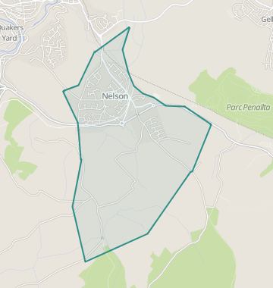
USEFUL TELEPHONE NUMBERS
Health Visitors
Nelson – 01443 878326/878327
Bedlinog/Treharris – 01443 410267

Social Services
Gwent – 0808 100 2500
Merthyr – 01685 721711

Local Pharmacies
Nelson Chemist – 01443 450240 (Sheppard’s)
Treharris Chemist – 01443 410268 (Parry’s)

JULY 2018

